Lab-8

Queries and screenshot:

1. Produce a list of text books (include Course #, Book-ISBN, Booktitle) in the alphabetical order for courses offered by the 'CS' department that use more than two books
2. List any department that has all its adopted books published by a specific publisher.

**1** select b.courseno,b.book_isbn,t.book_title from book_adoption b,text t

where

b.book_isbn=t.book_isbn and

b.courseno in (

select c.courseno from course c,book_adoption b

where

dept="CSE" and

c.courseno=b.courseno

group by b.courseno

having count(*)>2

);

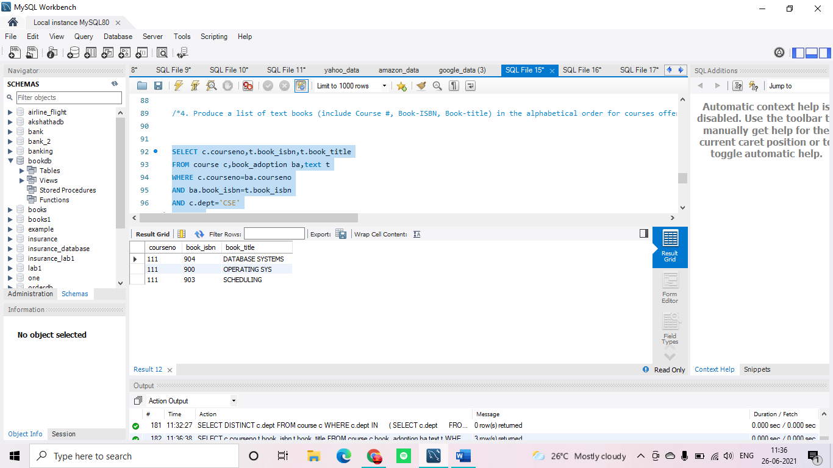

**2**  select c.dept from course c where c.dept in

(

select c1.dept from course c1,text t1,book_adoption b1

where

b1.courseno=c1.courseno and

t1.book_isbn=b1.book_isbn and

t1.publisher='HALL INDIA' and

c1.dept not in (

select c2.dept from course c2,text t2,book_adoption b2

where

b2.courseno=c2.courseno and

t2.book_isbn=b2.book_isbn and

t2.publisher!='HALL INDIA'

)

);

